**EE475 Fall’19**

**Homework 2**

**CAMERAs and SAMPLING**

1. **Camera**: A triangular billboard is placed in front of a camera with focal length of 1 cm. So that its three corners have three coordinates relative to the camera coordinate system (all in meters) of P1 = (-1, 1, 1), P2(4, 2, 2), P3(-3, 12, 3) where P(x, y, z), that is z is the depth in world coordinates. Give the coordinates of the vertices in cm in the image plane. Hint: Use similar triangles.

b) **Sampling**: Like an undulated roof or like a Benetton sweater, the image f(x,y) = 24∙cos4πx∙cos6πy has sinusoidal patterns:

i) How many horizontal and vertical cycles per meter does the pattern have?

ii) What would be the frequency encountered along 0, 30, 45, and 90 degrees?

iii) To represent this image digitally, what should be the Nyquist rate?

iv) How many samples will 1-meter square of this sampled texture will contain?

**HISTOGRAM EQUALIZATION**

Implement your own histogram equalization function in MATLAB. Try your function on the image “lumberjack” and “moon” images, and validate with “histeq.m” MATLAB function. Compare your results with adaptive histogram equalization method. You can use MATLAB embedded function “adapthisteq.m”. Do we always obtain better results with adaptive histograms? If so, why do? Comment on the results.

|  |  |
| --- | --- |
| **C:\Users\Sankur\Dropbox\DROP_MECA589\Histogram\lumbercamp.jpg**  Lumberjack | moon  Moon |

**HISTOGRAM FLATTENING and MATCHING**

**C**onsider the four face images. A) Do histogram equalization of each image, and B) Do histogram matching with respect to reference Image A. Display the images in quadriptychs. Note: Disregard 255 and 0 values in the image histograms, which are due to the background and to the black bars on the sides.

Find the histogram distances as a measure of how well we have accomplished histogram matching. Among many possible histogram distances, consider the following two (L-1 is the highest gray value):

1. The chi-square histogram distance between histograms p and q, namely:

.

1. The Kullback-Leibler distance

Compare the histogram distances before and after histogram equalization and histogram matching by listing them in two 4x4 tables.

|  |  |
| --- | --- |
| C:\Users\Bulent Sankur\Dropbox\EE475_2019\HW#2 Histogram_2019\lights\subject1_photo2.jpgA | C:\Users\Bulent Sankur\Dropbox\EE475_2019\HW#2 Histogram_2019\lights\subject1_photo3.jpgB |
| C:\Users\Bulent Sankur\Dropbox\EE475_2019\HW#2 Histogram_2019\lights\subject1_photo1.jpgC | C:\Users\Bulent Sankur\Dropbox\EE475_2019\HW#2 Histogram_2019\lights\subject2_photo1.jpgD |

**HISTOGRAM EQUALIZATON OF COLOR IMAGES**

**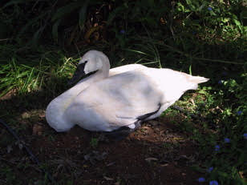 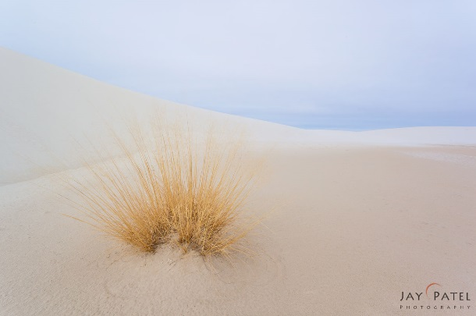**

**kugu.jpg beach.jpg**

1. Histogram equalize separately the RBG components of the kugu and the beach images, and then create the color image. Do you get a satisfactory result?
2. Histogram equalize the intensity component only while freezing the hue and saturation components, and then create the color image.
3. Histogram equalize the saturation component only while freezing the hue and intensity components; then create the color image.
4. Comment on the outcomes of the three color image histogram equalization methods.